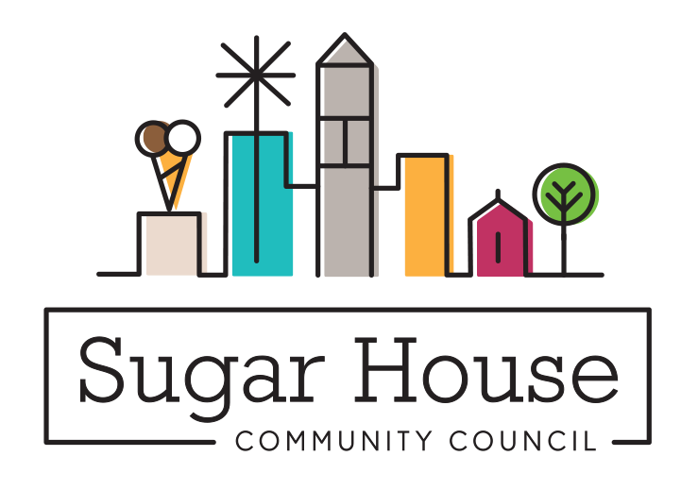

January 18, 2024

TO: Cassie Younger, Senior Planner
Salt Lake City Corporation

FROM: Judi Short, Vice Chair and Land Use Chair
Sugar House Community Council

RE: Adding Single Family Attached to Select Commercial Zones

TAG SLC has initiated a petition to add “Single Family Attached” as a Permitted use in Commercial Zones where “Multi-Family” is also permitted.

We presented this at our December 11, 2023 SHCC Land Use and Zoning meeting. There was not a big discussion, everyone seemed to think it made sense. We were reminded of the apartment over a store retail building that we used to have so many of. Why can’t a family have a home attached to their retail building, if there is enough room and it still allows for all the requirements of the business, like setbacks and parking?

We posted this on our website November 18, and this was in the Land Use Report included in the SHCC December newsletter. We have received no comments about this approval, and we recommend that you approve this text amendment to our zoning code.

