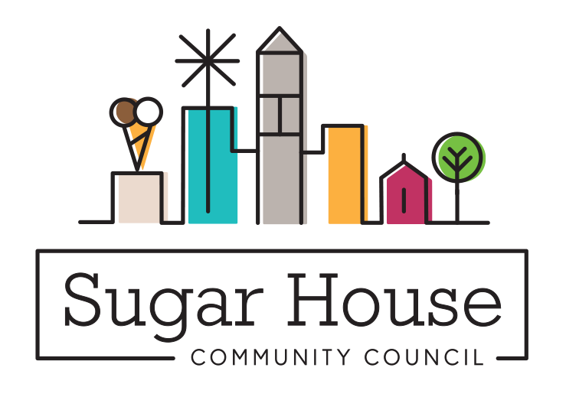

February 18, 2023

TO: Members of the Salt Lake City Council

From: Judi Short, First Vice Chair and Land Use Chair
Sugar House Community Council

RE: SLC Urban Forest Action Plan

I don’t recall that the Sugar House Community Council had an opportunity to weigh in on this report, unless there was a tabling event at Fairmont Park or something to catch a few passersby. So, most of what I am about to say comes from my experience as a Master Gardener, management of the gardens at Gilgal Sculpture Garden, and my knowledge of trees.

This report may be the most through report ever produced by Salt Lake City Corporation. I don’t find a consultant’s name attached, so I am giving full credit to Tony Gliot and his team in the Urban Forestry Department. We have been planting 1000 trees every year since 2020, and yet, many of the newly planted trees are dying. The report spells out the issues, the probable causes, and a number of solutions to solve the problem from many perspectives. We know we need trees – they make the air cooler and provide shade. They remove pollutants from the air, some better than others. You can read the details for yourself.

I recommend that you approve this report right away. February 21, 2023 is ideal. Then, instead of putting the report on the shelf and thinking about it again in a few years, you need to put together a committee right away, to make an outline of what needs to happen and what it will cost, so those figures can be included in the 2023-24 budget. Don’t put it off. Do it now. You need to develop a team of people who will work with citizens to teach them how to water trees correctly, all the things that are already on your website. (It is one of the best departmental websites of the Salt Lake City Corporation). Here are the items you should include, feel free to include others.
- The idea of Master Tree Gardeners is a terrific one. You can find them in neighborhoods, or perhaps high school or college students that maybe interested. Give them some skills, and maybe they will be next in line for a job in the Parks Department. We know you always struggle to find good workers, every summer.
- Target neighborhoods that have too many of the bad trees and educate them on which are the good ones to plant. Update the database every time a tree is planted.
- Teach the citizens, have them own the tree canopy. You didn’t even mention what a wonderful resource it is to have our own tree arboretum at the Salt Lake City cemetery. Maybe labeling the trees will help citizens see what a tree will look like when it grows up, so they make more informed choices.
- Teach them how to identify a tree in its declining years, and how to plant a replacement long before the declining tree needs to be removed. There are so many opportunities for the city, just in this one plan.
- Make sure the tree canopy is adequate everywhere in our city, and where it is inadequate, take the time to educate the citizens so everyone works together to make and keep a robust tree canopy.

What a terrific advantage we will have, to have the best tree canopy in the west, a city that was hot and bleak in many places, transformed into one that has enough shade and the right trees to make it enjoyable to be outside in July. Without more staff, and funding, this program will not succeed. Don’t hesitate. Begin this journey now!

Cc: Erin Mendenhall, Mayor
Tony Gliot, Forester
Kristin Riker, Director Open Lands

