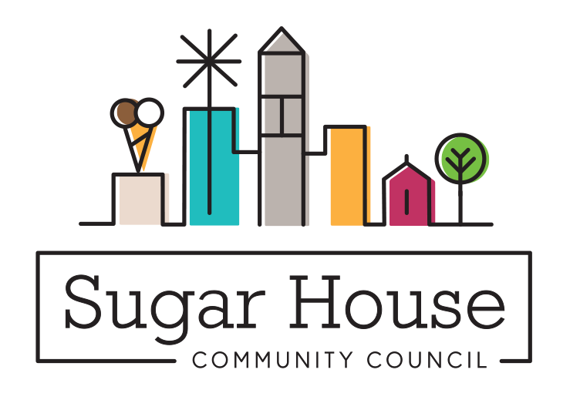

March 5, 2025

TO: Salt Lake City Planning Commission

FROM: Judi Short, First Vice Chair and Land Use Chair

Sugar House Community Council

RE: RMF-35 and RMF-45 Multi-Family Zoning District Merger

We know we need a lot of new housing in Salt Lake City, but this is not the way to go about it. The broad-brush approach won’t work for this. You need to go around and look at each specific building that is RMF-35, examine the surrounding neighborhood, and see if rezoning it to RMF 35 makes sense. And think about how you are going to require all the parcels be rezoned to RMF-45 to somehow be required to include a community benefit, should they be redeveloped. Or do they stay RMF-35 until much time as the owner wants to redevelop and get more units or height.

Many of the RMF 35 lots are very small, and not 50’ wide. In order to qualify for RMF-45, they may(will?) have to acquire an adjacent parcel to have the required width on the street to build something worthwhile in an enlarged parcel. Then the temptation is to try to come up with a community benefit, so it qualifies for 55’. And hopefully that means that some affordable housing will be built. That is the upside. The downside is that the buildings that were on the original two lots that were combined, probably had units for rent that were affordable, or maybe a house that could be purchased at a lower value. And, if there are houses on either side of the new parcel, they now would have a 55’ building 5’ from their property line.

Think of a block in the city that has mostly RMF 35 on it. Those buildings are probably 20-35’, and now there is a 55’ larger apartment building in the middle of the block. The lots are required to be no more than 110’ wide. That limits the size of the new 55’ building. Depending on what the developer paid for the parcels, to make a project pencil, she has to figure out the cost of demolition, building and materials for the new building, minus potential rent, which might be lower for the two or more affordable units that are required for the public benefit. There are considerable blocks like this in Central City and the Avenues, what does such a change do to the fabric of these neighborhoods? We do not think that this look would fit into our neighborhoods very well, which is why we think Salt Lake City needs to go parcel by parcel, or at least block by block, and make a conscious choice about whether a building is on the list to be rezoned. Don’t have a goal of rezoning every RMF-35 building to RMF-45 just because you can.

You should look carefully at these numbers in areas of town where the houses are more like bungalows, 20-25 feet tall, and the blocks are significantly smaller, like the Avenues and parts of Central City. A parcel 110’ wide with a 55’building on it would look ridiculous, and the charm of the neighborhood will be gone.

You should take condominiums out of this conversation. They are already built, and won’t be touched by this proposal.

Have you ever thought about the huge cost of upgrading sewer and water to these parcels? Remember what requiring a separate sewer and water line did to the development of ADUs a few years back? For these 55’ buildings, the costs will be enormous and you have just wiped out any thought of affordable units in the building.

We are pleased to see this zone has design standards. This will help with how the building looks. It would not be hard to build a new building that has the look and feel of something that was built 50-60 years ago, We would not like to see 5 over 1 podium construction in these neighborhoods. Where that building type has been used in Salt Lake City, they are much less attractive and tend to look shabby quickly.

Thriving in Place aims to protect residents from displacement. Taking away existing affordable housing one building at a time doesn’t achieve that. It calls for preserving the affordable housing that currently exists. Most of what will be taken down will be our existing affordable housing. Building new housing doesn’t easily result in more affordable units, because new construction costs more now than it did when these buildings were built 40-60 years ago.

The Sugar House Master Plan says for medium-density residential “Encourage new Medium-Density housing opportunities in appropriate locations in Sugar House. Encourage a variety of densities in the Medium-Density range while ensuring the design of these projects is compatible with the surrounding residential structures.” The policy for medium-high density residential development: “Support opportunities for conversion and infill development of Medium-High Density housing while requiring appropriate design and location to minimize land use conflict with existing single-family development.” And Residential Implementation Strategies: “Evaluate the zoning ordinance to identify any impediments to providing new housing options within the community.” We would expect that any new projects approved by planning would meet these requirements.

Saving water is a good thing, but it seems counterproductive to take out most of the green space we now have, which means it will be harder to keep trees alive if their roots are confined. As our air quality deteriorates, we will need more, not fewer trees to help clean the air. Trees do this by removing pollutants and lowering the temperature of the air.

We think your brush was too broad when you started this project. We know it is easier to just rezone everything in a certain category, but there are times when it does not result in the best product. Take another look, even though it will mess up your timeline. Take out the parcels where it won’t make a difference or could even make it worse to be RMF-45.