October 10, 2025

To the Salt Lake City Planning Commission:
RE: PLNPCM2025-00622
PLNPCM2025-00644

It has come to the attention of the Parley’s Rails Trails and Tunnels Board (PRATT) that a new project has been proposed for the parcel located on the southeast corner of 1300 East and 2100 South. A developer has presented plans to build a multi-story hotel at the site of a closed Sizzler restaurant.

The Parley’s Trail and the Sego Lily Plaza are located directly south of the parcel. This trail is a paved bike and pedestrian trail that is highly utilized and accessible to people of all ages and abilities. It stretches from Parley’s Canyon to the Jordan River Parkway. The Sego Lily Plaza is one of the largest outdoor environmental art installations in SL County. It is an area of the trail that provides interest and respite during a ride or walk through Sugar House Park.

We have concerns that the hotel construction will be detrimental to the Sego Lily Plaza and the Draw which connects Sugar House Park to Hidden Hollow in the heart of Sugar House. The Lily was designed by renown environmental landscape artist Patricia Johansen, who has instillations located throughout the world.

In addition, the Sego Lily Plaza is an art installation placed on top of an earthen dam that was designed for flood control for Sugar House Park and 1300 East. This dam was constructed with the approval of the Utah State Division of Dam Safety in 2014. We are concerned that disruption of the land to construct a multi-story underground parking structure will compromise the integrity of the dam and threaten Parley’s Trail and the Sego Lily Plaza.

A thorough engineering analysis should be completed and considered before any permits are approved for this project.

Respectfully,
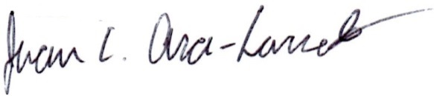

Juan Arce-Larreta
PRATT Board Chair

